Questions-1 Scanning

Task-1 Step-up the lab in your local system after download it.

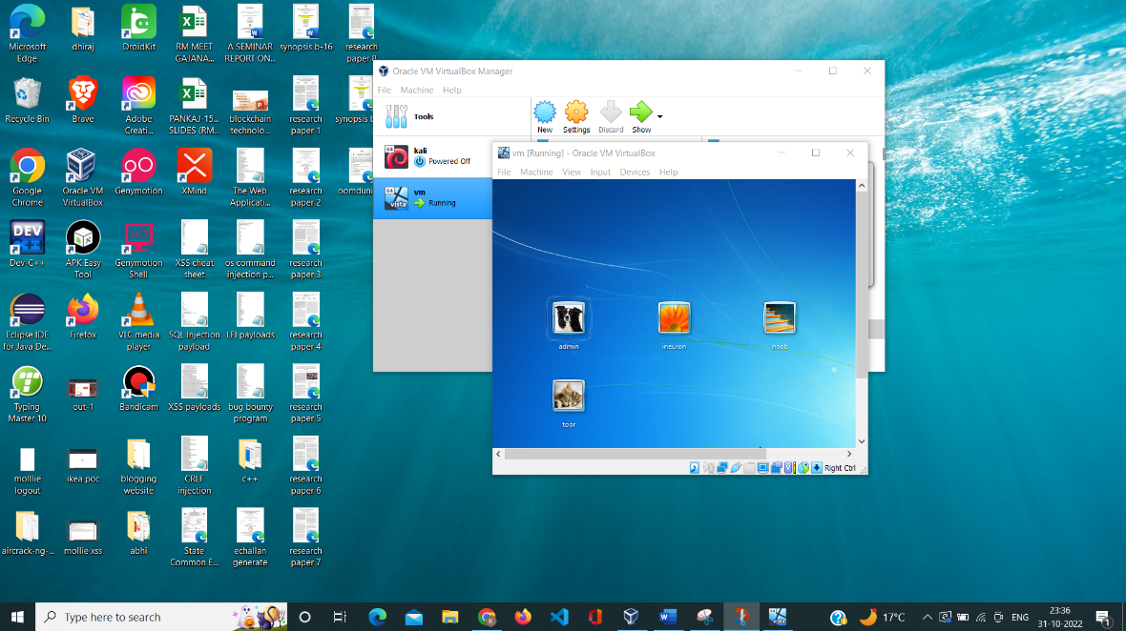

Part B - Investigation Phase

Question-6 Wireshark Analysis

q-1 There is a very popular tool by Van Hauser which can be used to brute force a

series of services. What is the name of this tool?

Ans:- Hydra

q-2 The attacker is trying to log on with a specific username. What is the username?

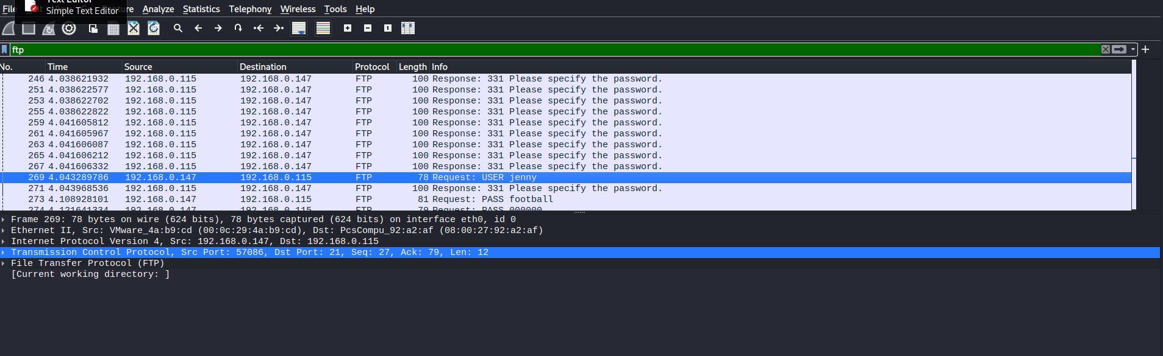Ans:- jenny

q-3 What is the user’s password we found in the analysis?

Ans:- password123

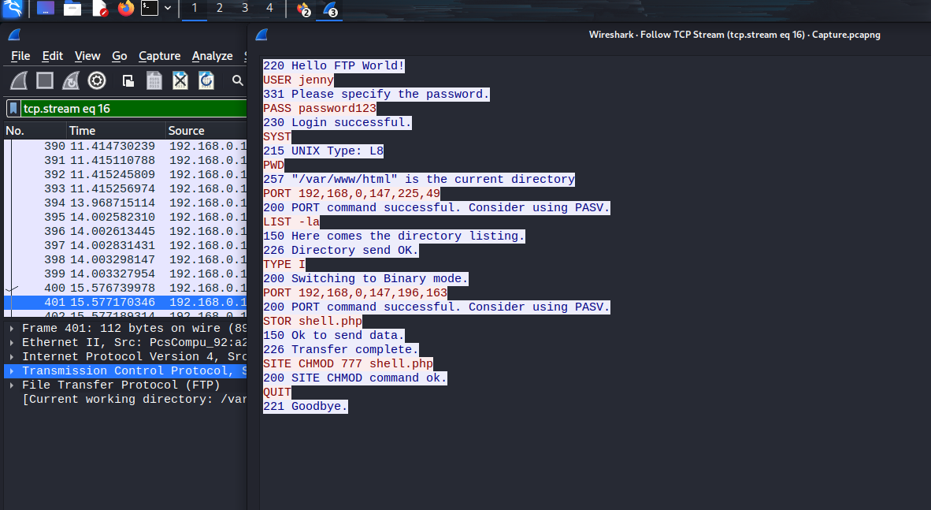

q-4 What is the current FTP working directory in the analysis process?

Ans:- /var/www/html

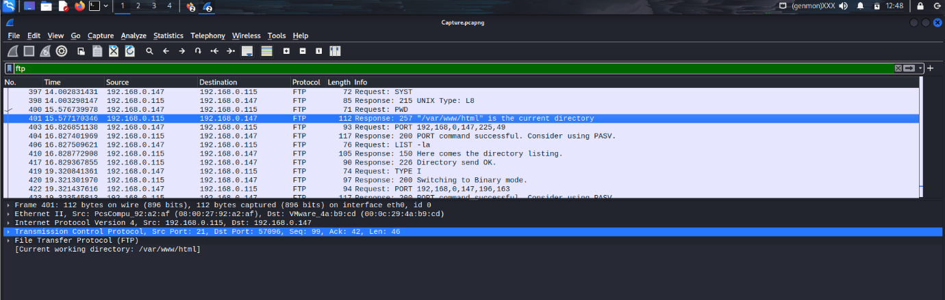

q-5 The attacker uploaded a backdoor. What is the backdoor's filename?

Ans:- shell.php



q-6 What is the computer's hostname?

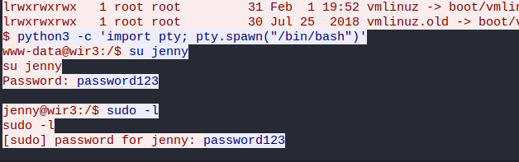Ans:- wie3

q-7 Which command did the attacker execute to spawn a new TTY shell? here we

asking about the python command we use to invoke an interactive shell?

Ans:- python3 -c 'import pty; pty.spawn("/bin/bash")'



q-8 The project can be used to install a stealthy backdoor on the system. It can be very

hard to detect. What is this type of backdoor called?

Ans:- rootkit